Practical 5
- Calculate test statistic for paired or non-paired data
- Convert to p-value
- Make decision. If p is small (p<0.05), then reject H0 (statistically significant). If p is not small, then do not reject H0 (not statistically significant; observed differences= chance)
- Conclusion. Summarize medical question, result, and include p-value
- Observed frequencies in the sample of 308 patients divided according to presence of PAP and HLA-DR4

PAP | HLA-DR4
PAP | Present | Absent
Present | 46 | 28
Absent | 50 | 184

- Estimate results of hypothesis testing in Epinephrine test:

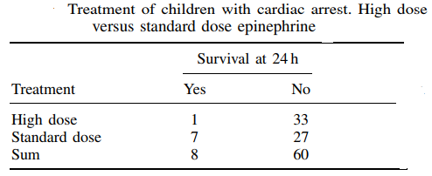
(Source: STATISTICS IN MEDICINE Statist. Med. 2009)

- Estimate results of hypothesis testing in The genotype—exfoliation example:
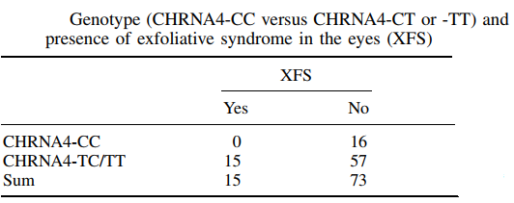
(Source: STATISTICS IN MEDICINE Statist. Med. 2009)

- Results of the study to examine whether intra-muscular magnesium is better than placebo for the treatment of chronic fatigue syndrome.
Outcome | Magnesium | Placebo
Felt better | 12 | 3
Did not feel better | 3 | 14
(Source: Freeman JV, Julious SA. The analysis of categorical data. Scope 2007)
- Table of treatment (clinic/home) by outcome (ulcer healed/not healed) for the leg ulcer study. Calculate and make conclusion about treatment efficiency. (Source: Freeman JV, Julious SA. The analysis of categorical data. Scope 2007)

Outcome | Treatment
Outcome | Clinic | Home
Healed | 22 | 17
Not healed | 98 | 77

- Jackson et al. (2013) wanted to know whether it is better to give the diphtheria, tetanus and pertussis (DTaP) vaccine in either the thigh or the arm, so they collected data on severe reactions to this vaccine in children aged 3 to 6 years old.

 | No severe reaction | Severe reaction
Thigh | 4758 | 30
Arm | 8840 | 76

- Trace metals in drinking water affect the flavor and an unusually high concentration can pose a health hazard. Ten pairs of data were taken measuring zinc concentration in bottom water and surface water. Does the data suggest that the true average concentration in the bottom water exceeds that of surface water?
Bottom | Surface
0,43 | 0,415
0,266 | 0,238
0,567 | 0,39
0,531 | 0,41
0,707 | 0,605
0,716 | 0,609
0,651 | 0,632
0,589 | 0,523
0,469 | 0,411
0,723 | 0,612

- Six subjects were given some medicine (treatment group) and another 6 received placebo (control group). The reaction time was recorded (in ms). Was the treatment effective?

Treatment group | Control group
101 | 91
110 | 91
103 | 87
93 | 99
99 | 77
104 | 88

- The study revealed the influence of certain type of surgery on the leukocyte level in blood of animals. The blood samples were taken for test before and after the surgery. Find if the surgery had any significant changes in leukocyte level.

Leukocytes
Before surgery | After surgery
10,8 | 10,6
12,9 | 16,6
9,59 | 17,2
8,81 | 14,0
12,0 | 10,6
6,07 | 8,6

- Blood Pb (lead) concentration in the blood ofoccupationally exposed and non-exposed workers were examined.

Battery workers (occupationally exposed) | Control (not occupationally exposed
0,082 | 0,04
0,080 | 0,035
0,079 | 0,036
0,069 | 0,039
0,085 | 0,040
0,09 | 0,046
0,086 | 0,040

- Study involved 6 subjects acting as their own control. Their blood cholesterol level was measured during fasting and after meal.

Patient | Fasting cholesterol | Postprandial cholesterol
1 | 198 | 202
2 | 192 | 188
3 | 241 | 238
4 | 229 | 226
5 | 185 | 174
6 | 303 | 315

